**CONNECTWITH.ME BUSINESS CARD DOCUMENTATION FOR USERS**

**For users who have not signed up on connectwith.me yet, follow these instructions (if you have already signed up, go to page 7 instead):**

* **Step 1: Sign up**

**Sign up by clicking on the sign up button**

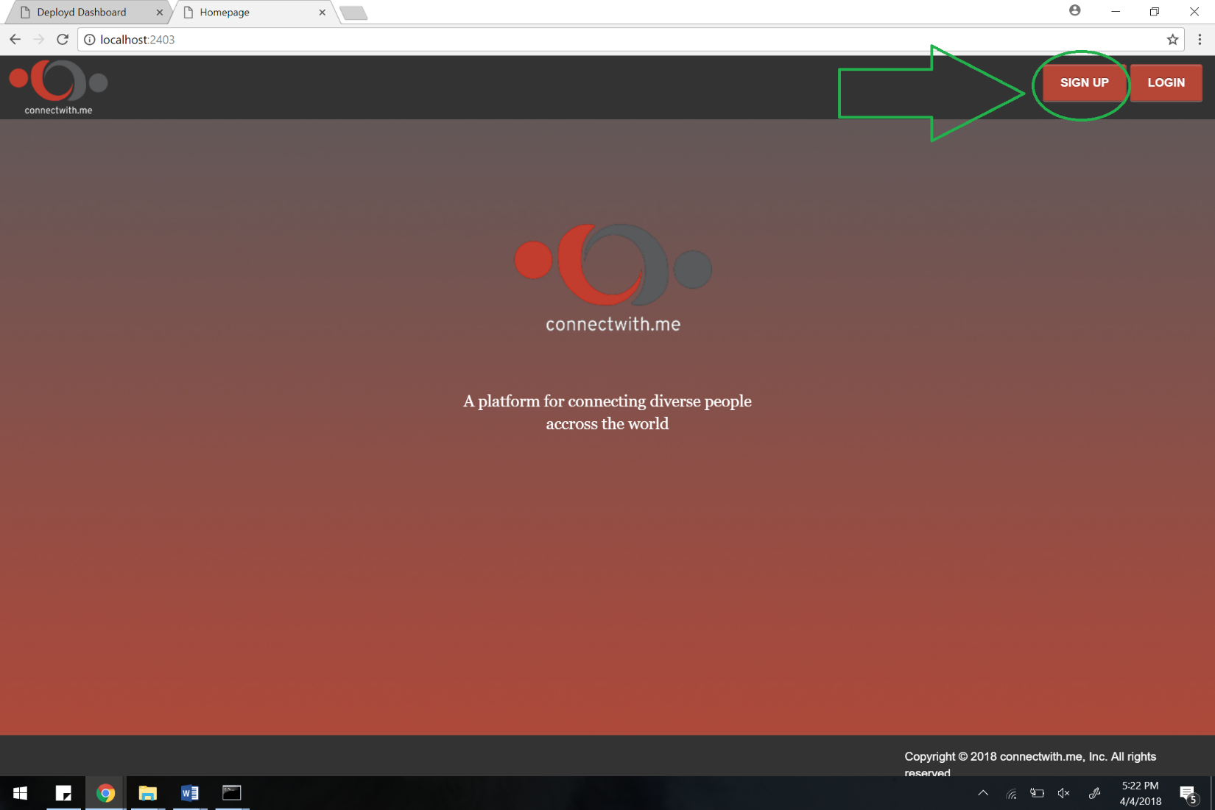

* **Step 2: Fill out sign up form**

**After clicking the sign up button from step 1, you will be prompted to fill out the sign up form**

**You should enter the following information to complete the sign up form:**

**First name**

**Last Name**

**Profession**

**Username**

**Password**

**E-mail address**

**Phone Number**

**Personal Information**

**Facebook URL**

**LinkedIn URL**

**Photo of yourself**

**After entering this info, click the submit button at the end of the form**

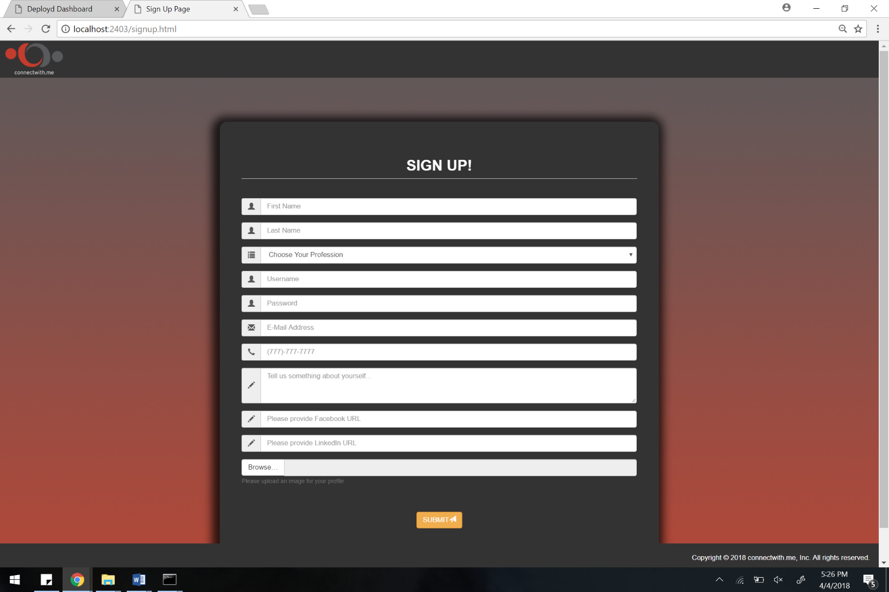

**Example of filled out form:**

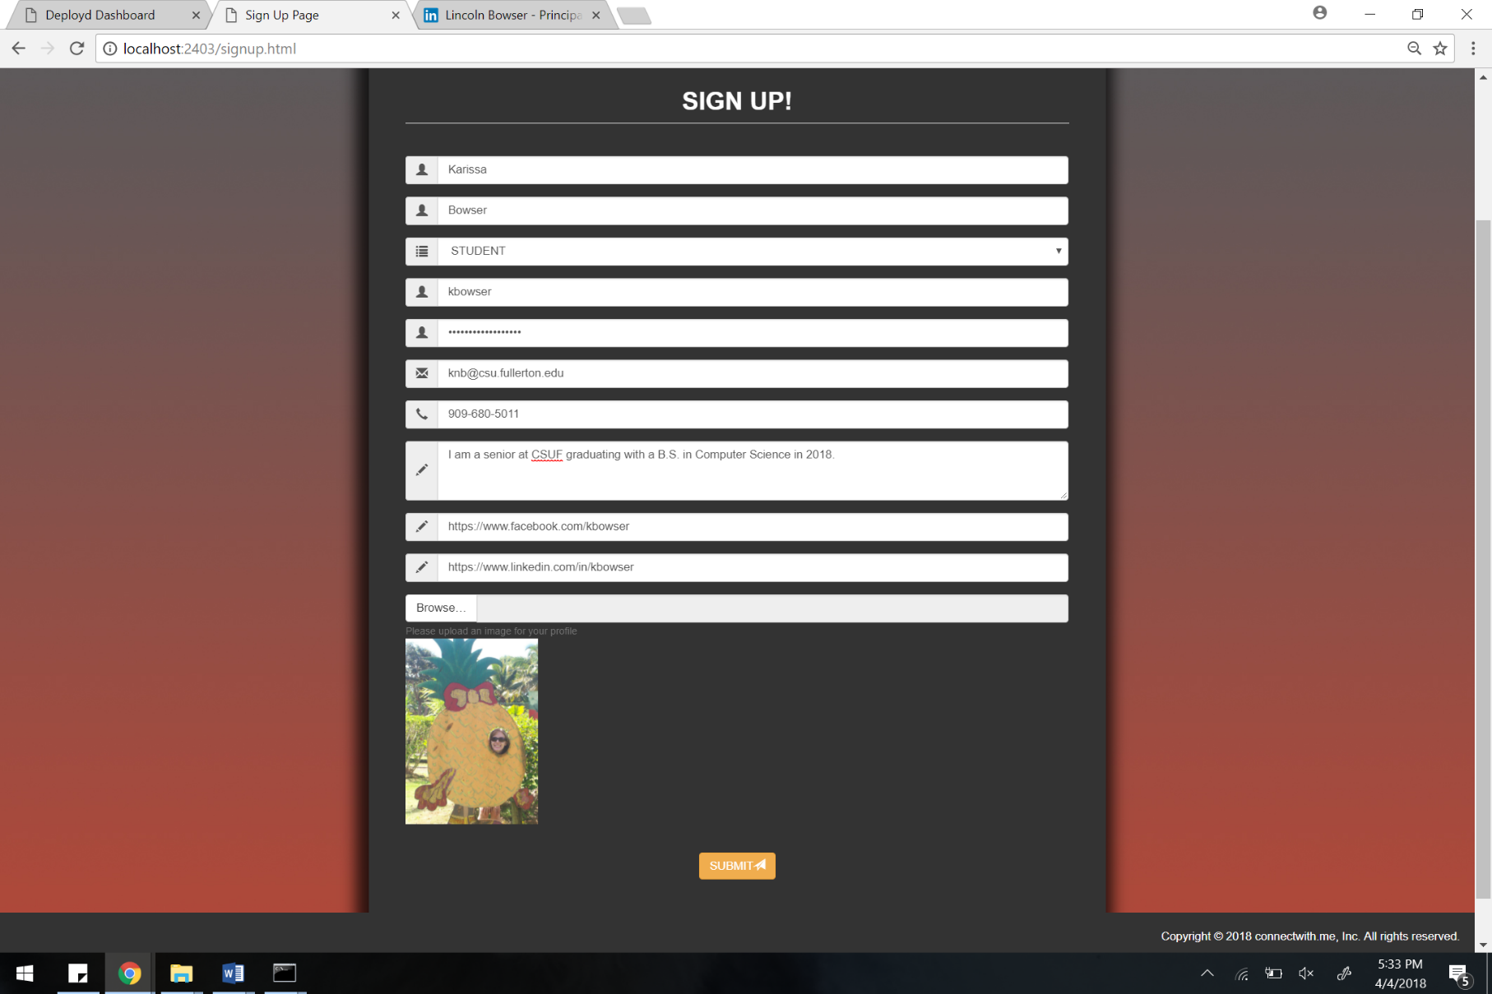

**Once the form is filled out, just click the submit button at the bottom of the screen.**

**Now you’ve created your business card on connectwith.me!**

* **Step 3: Login**

**Now you will be prompted to login with your username and password**

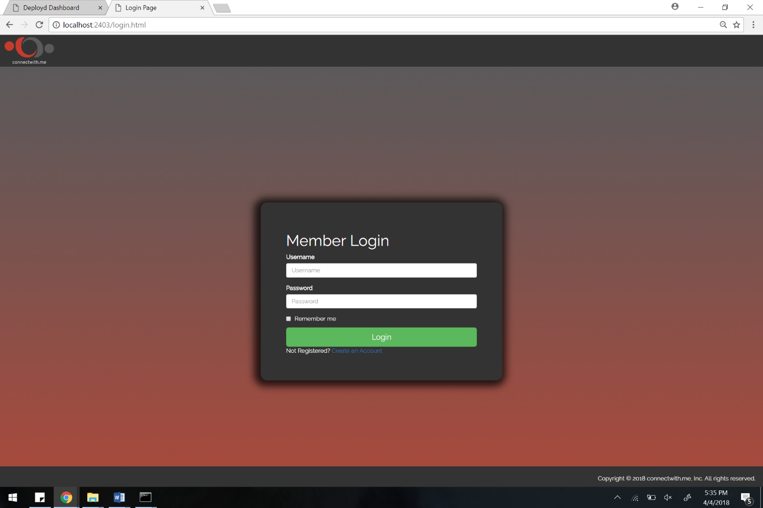

**Example of logging in:**

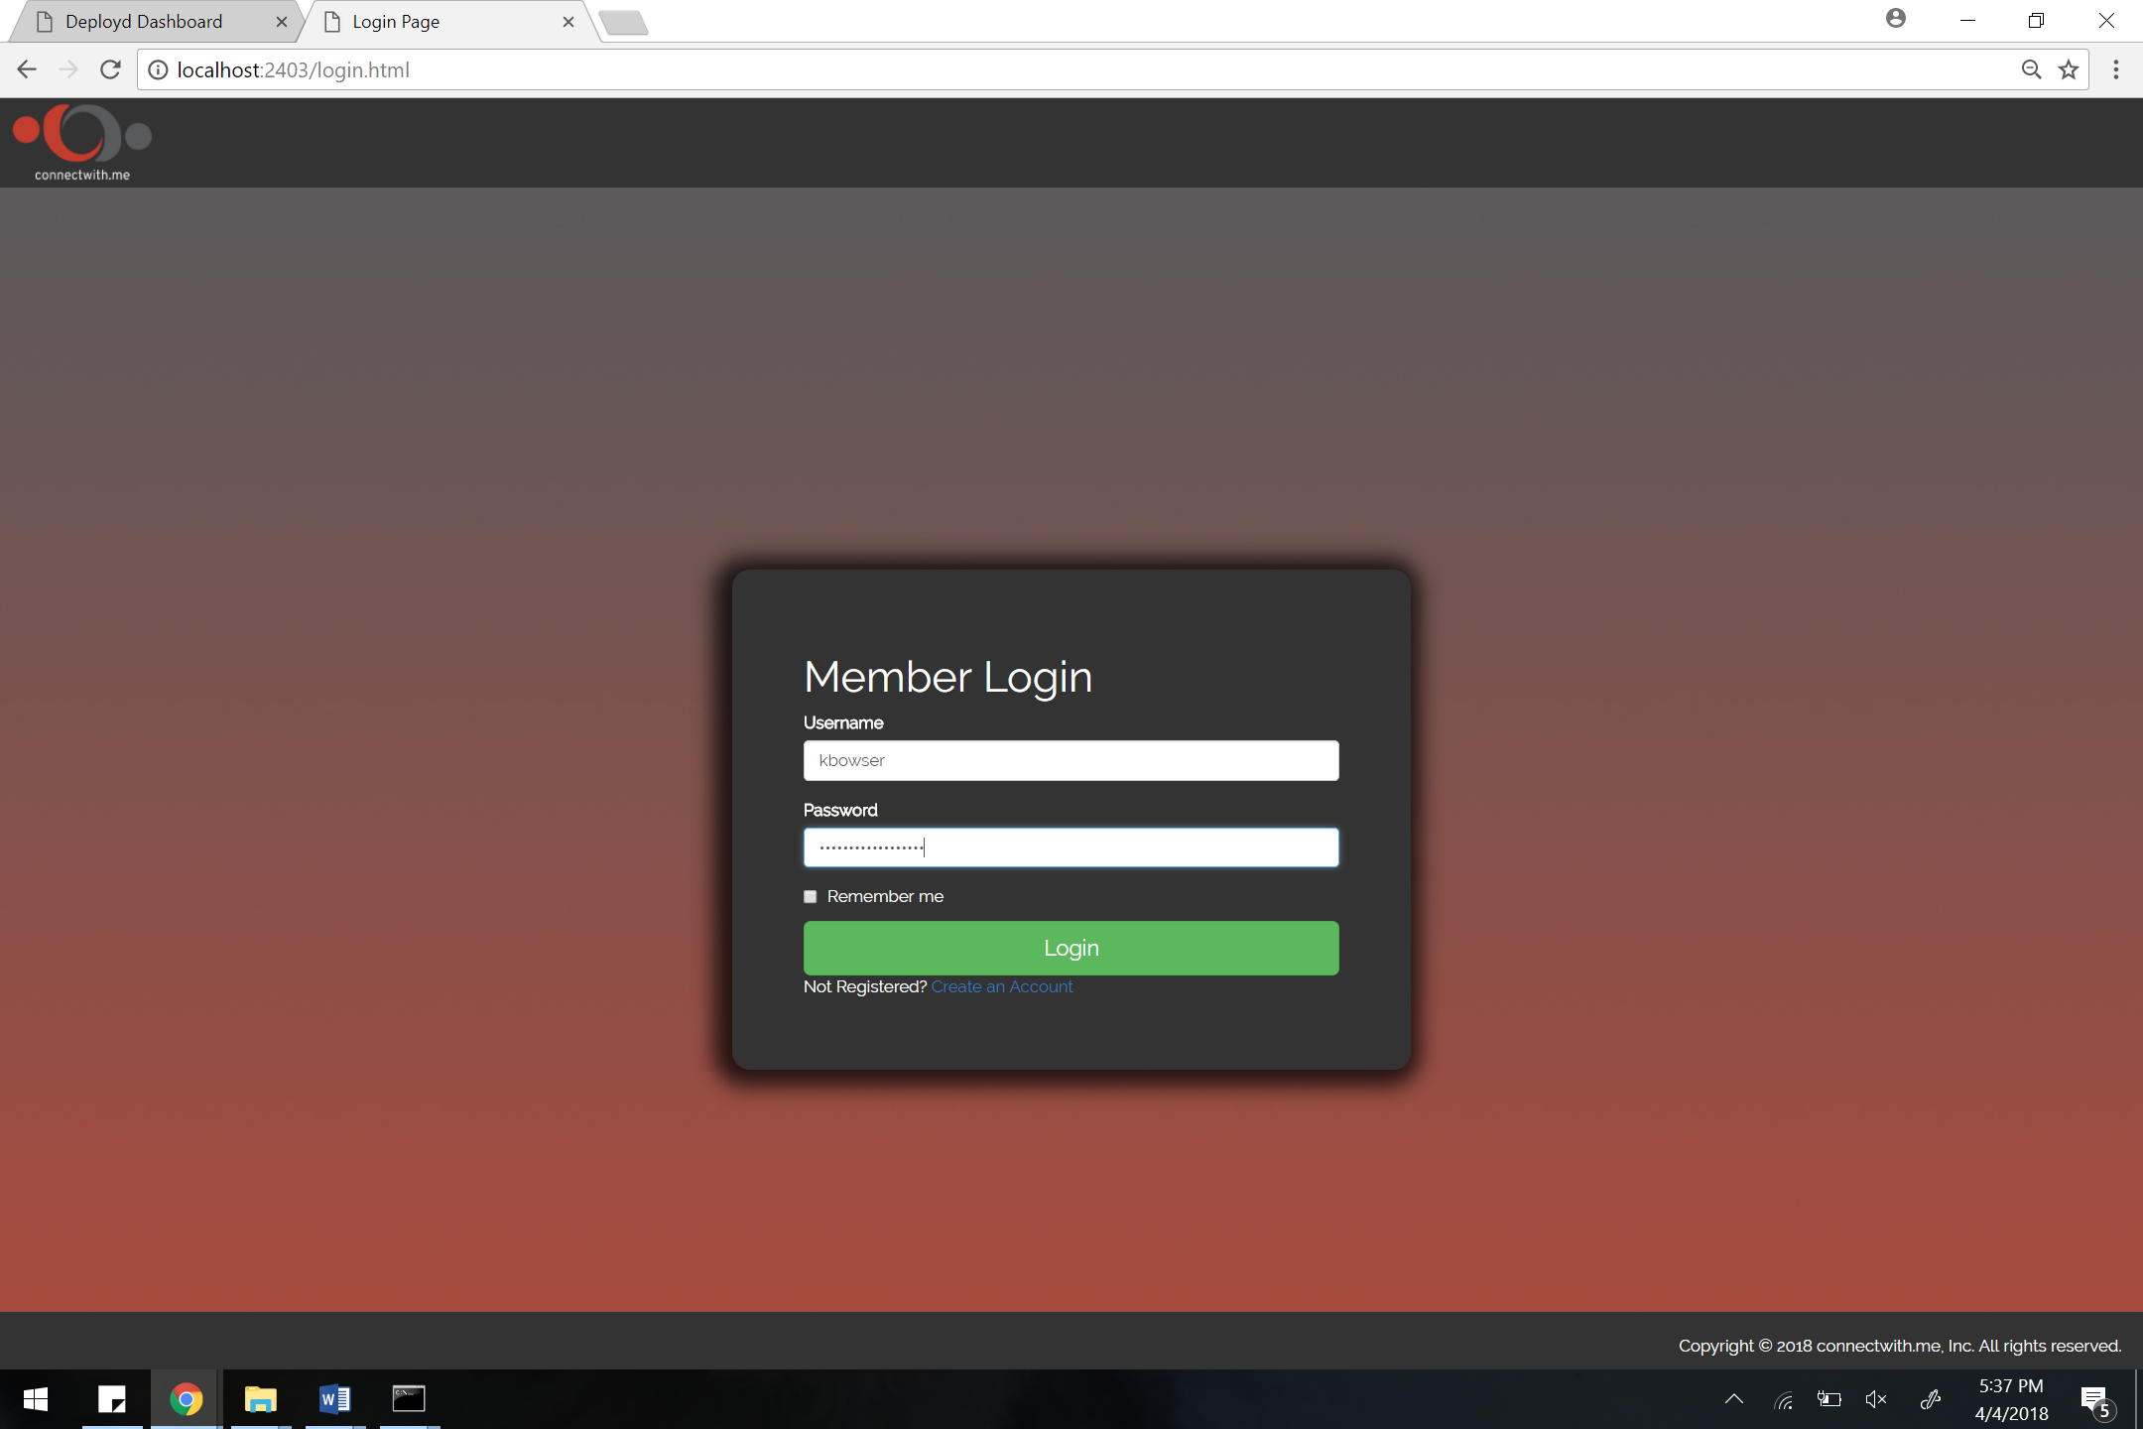

**After entering your username and password, just click on the login button.**

**Then you will see your business card:**

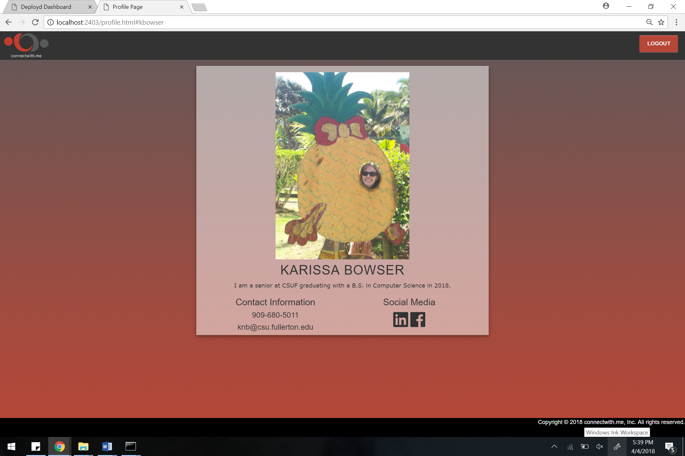

**Congratulations, you’ve finished creating your business card on connectwith.me!**

* **Step 4: Logout**

**When you’re done don’t forget to logout by clicking on the LOGOUT button at the top right corner of the screen!**

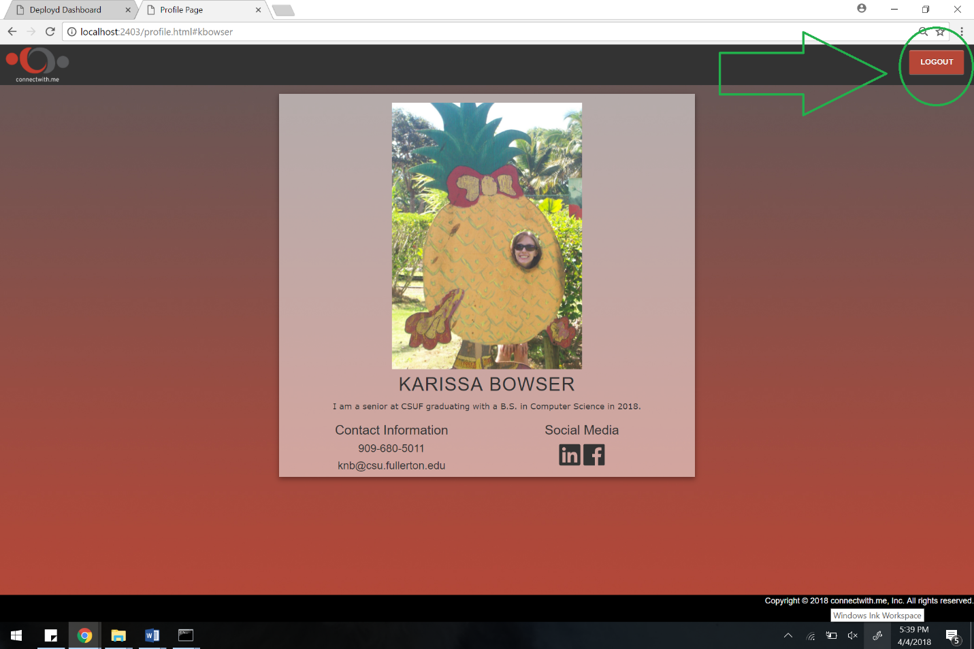

* **Step 5: Share your connectwith.me business card**

**Once you’ve logged out you can share your business card using the following format (provided you have dpd installed and have the correct configurations):** [**http://localhost:2403/profile.html#yourusernamehere**](http://localhost:2403/profile.html#yourusernamehere)

**Just replace your username with the text following the # symbol**

**Example:** [**http://localhost:2403/profile.html#kbowser**](http://localhost:2403/profile.html#kbowser)

**For users who have already signed up on connectwith.me yet, follow these instructions:**

* **Step 1: Login**

**Click on the login button to login, then enter your username and password once prompted**

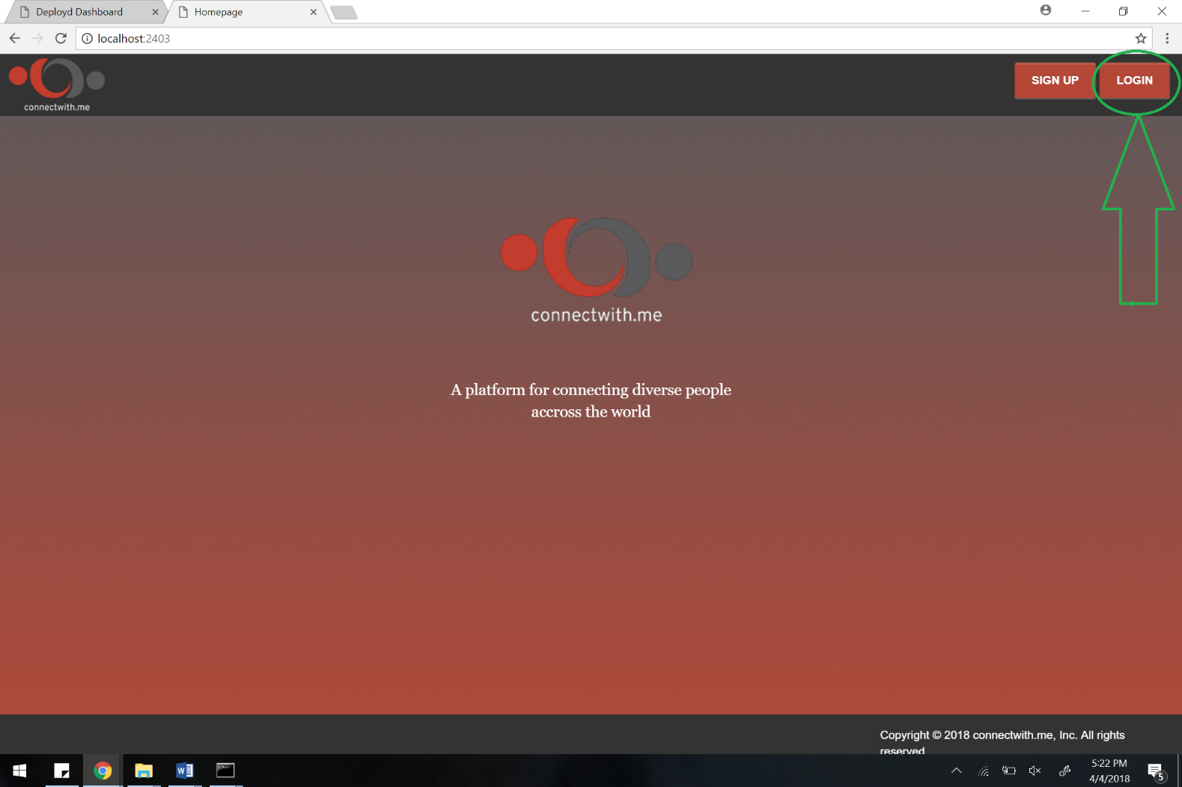

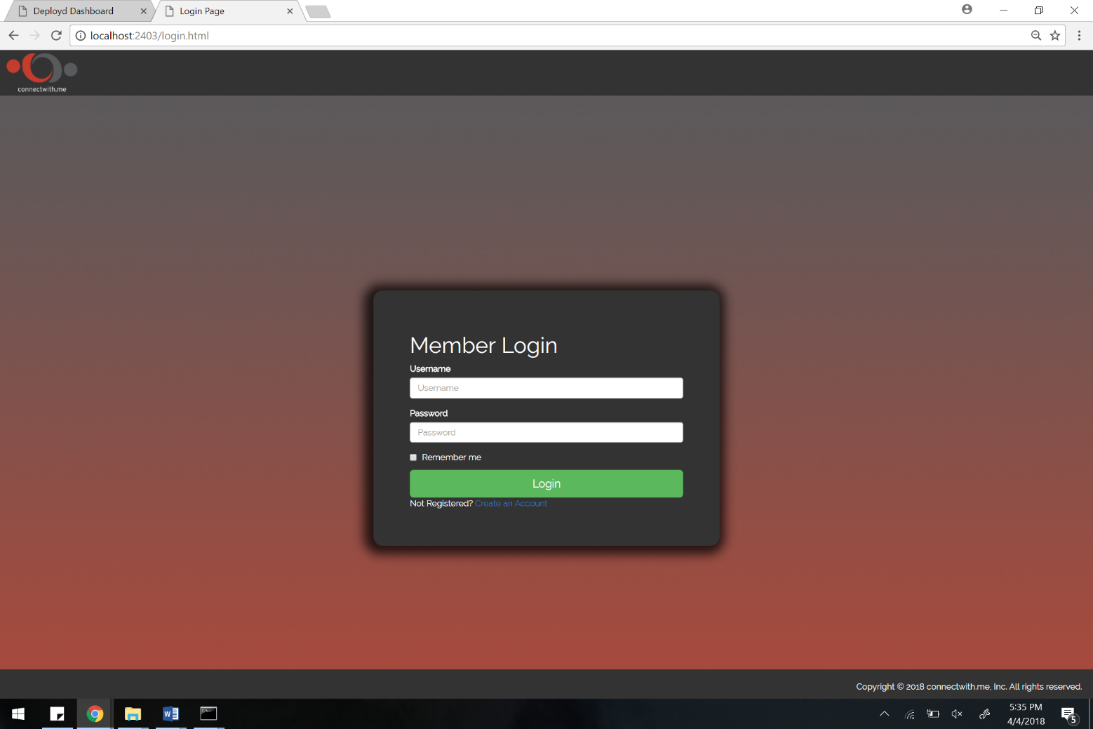

**Example of logging in:**



**After entering your username and password, just click on the login button.**

**Once you click the login button, then you will see your business card:**



* **Step 2:**

**When you’re done don’t forget to logout by clicking on the LOGOUT button at the top right corner of the screen!**



* **Step 3: Share your connectwith.me business card**

**Once you’ve logged out you can share your business card using the following format (provided you have dpd installed and have the correct configurations):** [**http://localhost:2403/profile.html#yourusernamehere**](http://localhost:2403/profile.html#yourusernamehere)

**Just replace your username with the text following the # symbol**

**Example:** [**http://localhost:2403/profile.html#kbowser**](http://localhost:2403/profile.html#kbowser)

**Thank you for using connectwith.me!**